INDIVIDUAL FINAL REPORT

DATS 6202 – Machine Learning 1

**Introduction**

This is a project that shows an implementation of a facial recognition algorithm using Haar cascades with gradient and Histogram of Gradients (HOG) algorithms. Haar cascades uses Haar-like features and detects edges and lines by using kernels (such as 3x3 pixels). When the algorithm detects a face like pattern, it classifies it as a face. In addition to Haar cascades, we added gradients to somewhat help with out facial recognition. Although a bit better, it still needs to train with a bigger dataset. HOG facial recognition algorithms on the other hand, uses gradients to detect and recognize faces. This is a little bit slower but effective in recognition and classification. Our project showcases both of these algorithms to help viewers compare the difference between the two. We also added some other features such as gradient view mode to show how gradients look on camera, implemented web scraping from Instagram profiles, as wells as Dash Plotly web application for a better user experience.

Our team of two shared work on everything and was there for each other for the whole process. From ideas, to coding, from papers, to presentations, and also doing calculations needed for the project. Both members were active in participating and the result was a good, clean working application.

**Description of Individual Work**

We basically did everything together, constantly having video chats on how everything is working. From ideas, to the coding to the presentation. For the ideas, it was mostly Cristina initiating. She has many ideas and we would talk about if it would work or not. When we started, the big issues were packages since one computer is Mac and one is Windows. We have different versions of codes but are pretty much the same since we would build up on what the other person added.

For the teamwork, we were working on Haar initially because it worked on both computers. HOG did not work on mine. Cristina discovered that it was more accurate in recognition, but HOG didn’t work on mine due to space issues. So, I decided to wipeout and reformat my computer and eventually, HOG worked. In the first half, I was more involved. In the second half, she was making a lot of it work and we were both really happy with our result. Although there are slight variations on our current codes, mostly aesthetics and user interface issues, it is pretty much the same. I am not sure what Cristina thinks, but I think we really worked well as a team since both of us are really involved.

For the coding, whenever we had problems, we would consult the other person if they can help with the code one person would push it, and the other person would look at how to debug it. We decided that we would claim and share 50/50 of the credit for work on the individual description part since there was really no “individual parts” we were coding it together the whole time and working late. Even with the cleaning up of the folders and cleaning up of the code, we were both involved. In addition, the documentation was also done in equal parts. We are both very present on communication even on non-free times.

We were both doing so much that I think there was a mini competition on who’s version is better, but we didn’t want to compete and decided that we would build up and merge our codes and features every time we update. I really think we worked great as a team.

For the presentation, I created the PowerPoint initially, but of course had to consult and talk about how we are going to present. Cristina added slides and recommendations on the presentation, and we rehearsed enough times to have confidence presenting in class.

**Shared vs Individual Portion of the Work**

To begin with, we started playing around with image detection and made it work. We then moved on to live webcam face detection using Haar Cascades. When we moved to facial recognition, we added gradients to the Haar Cascades to make it work a little bit better. We then implemented another feature called web scraping. It takes the Instagram details of the person identified and trained through the algorithms. We made a switched from Haar to HOG since we figured out it worked better at recognition with small datasets. We tried to do Convolutional Neural Network, but the problem was that it took so much computing power that image processing and training took more than 4 hours. It is too time consuming and we would need to upgrade our hardware to continue with this. We decided not to follow through this feature and stayed with HOG. We continually fixed bugs and error created through the process. We added another feature and put it in the Dash Plotly web application as a host for our user interface.

For Plotly, we added buttons for training, capturing images, HOG and Haar Webcam feeds, Gradient Demo, and a Stop button to stop the Webcam feed. After creating the buttons, we then implemented the corresponding files and classes when the button is clicked. This resulted in an output in the Web applicaton screen. Then, we made the training easier with a capture option for the user so they can also try and use our demo.

We then created separate HOG, Haar and gradient folders, cleaned up the code, and made other folders as needed. We also created a Readme.md file for the code. There are two versions, one can be run on Physhell and one can be run on Pycharm both basically do the same thing. We then created the group report and the group presentation together and checked the project outline if we were missing something.

**RESULTS**

The result of the project is an application using a local host that can detect and recognize faces. The recognition depends on whether the model is trained to recognize a specific face. The project pulls information from the identified Instagram user’s account and displays it on the web browser along with a box that detects the face. The application is easy to use, and anyone can capture images and re-train the model to recognize their face and pull information from their Instagram account. They can also compare the speed and accuracy of the two models used in the project namely Haar and HOG. In addition, they can view the camera on gradient mode so that they can see how these two models view the environment to remove some bias.

**Face Detection**

Image Detection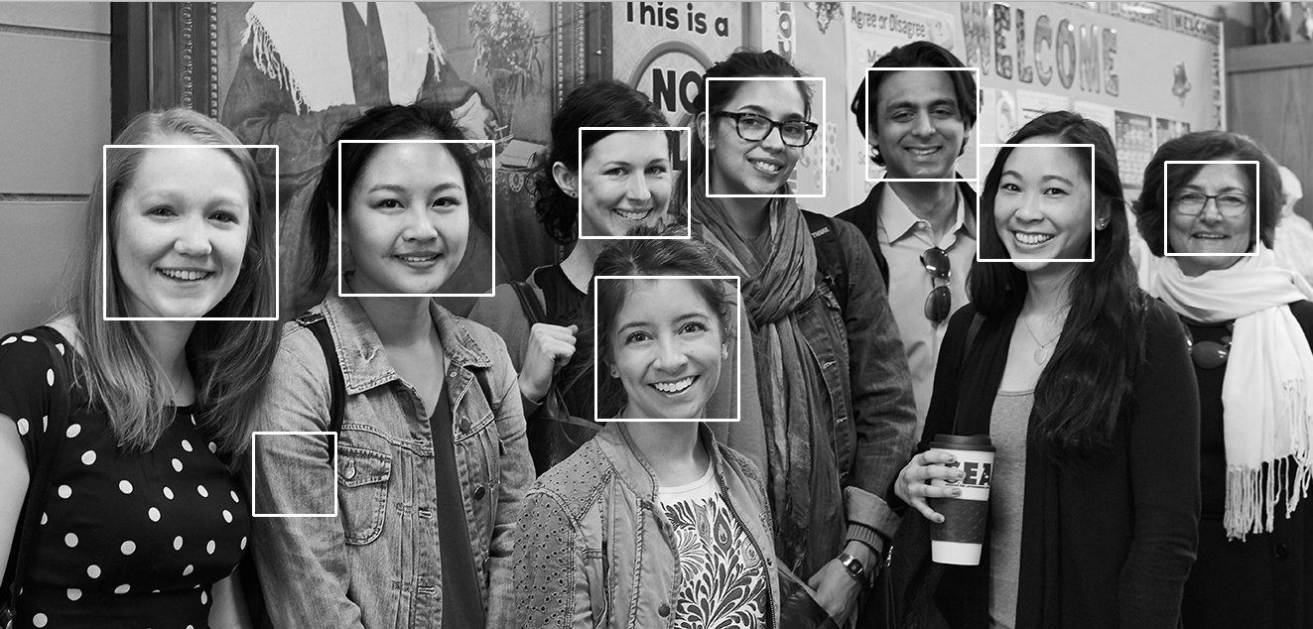

Haar Live Webcam Feed 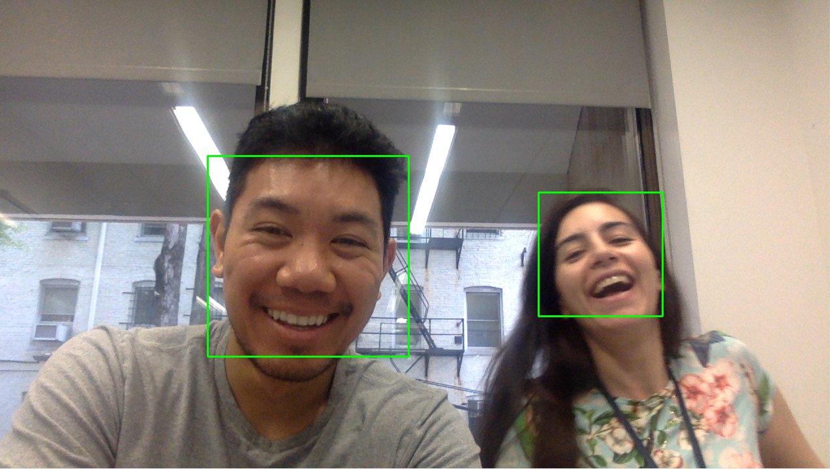

Haar Live Webcam Feed with Gradients HOG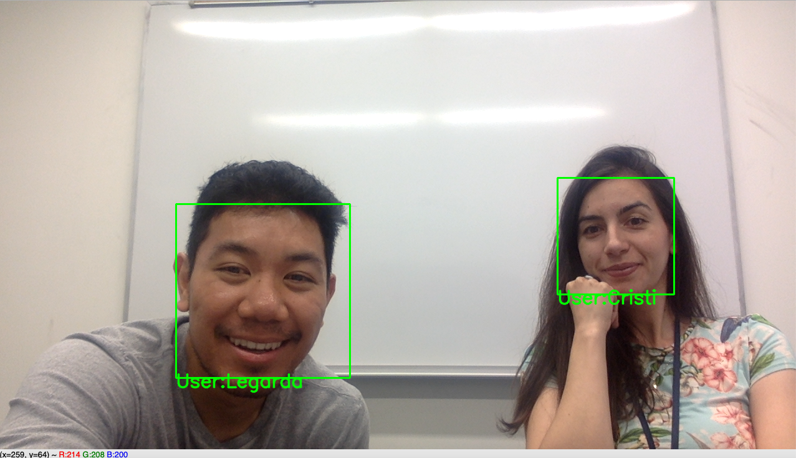

**Facial recognition with web scraping**

Haar Cascades was very fast and very good at detecting faces but was inaccurate. We made it work at some point, but we needed a bigger data set.

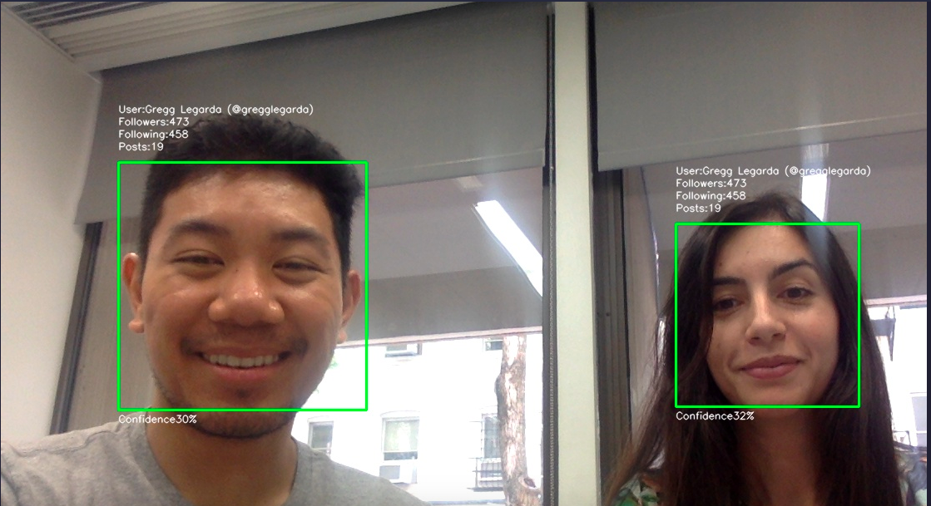

HOG on the other hand was slower but is more accurate, there were no problems with recognition.

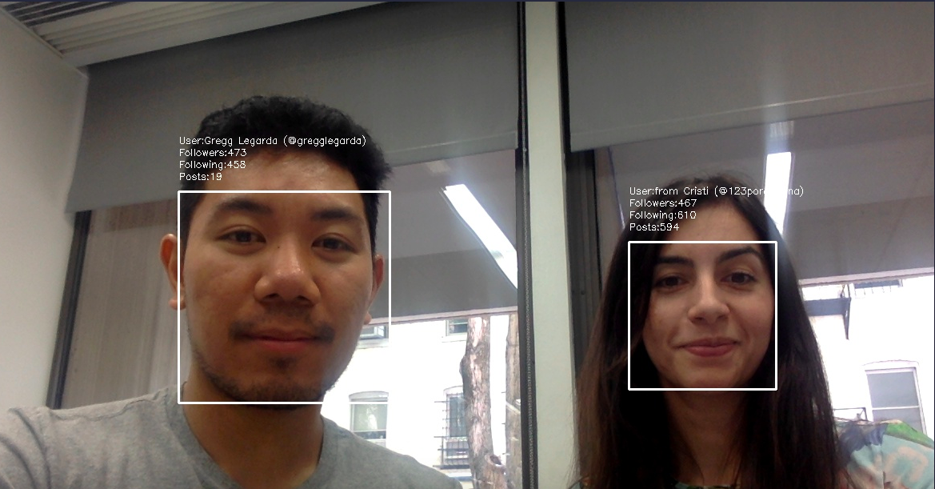

Results. Describe the results of your experiments, using figures and tables wherever pos- sible. Include all results (including all figures and tables) in the main body of the report, not in appendices. Provide an explanation of each figure and table that you include. Your discussions in this section will be the most important part of the report.

**Added features**

Gradient View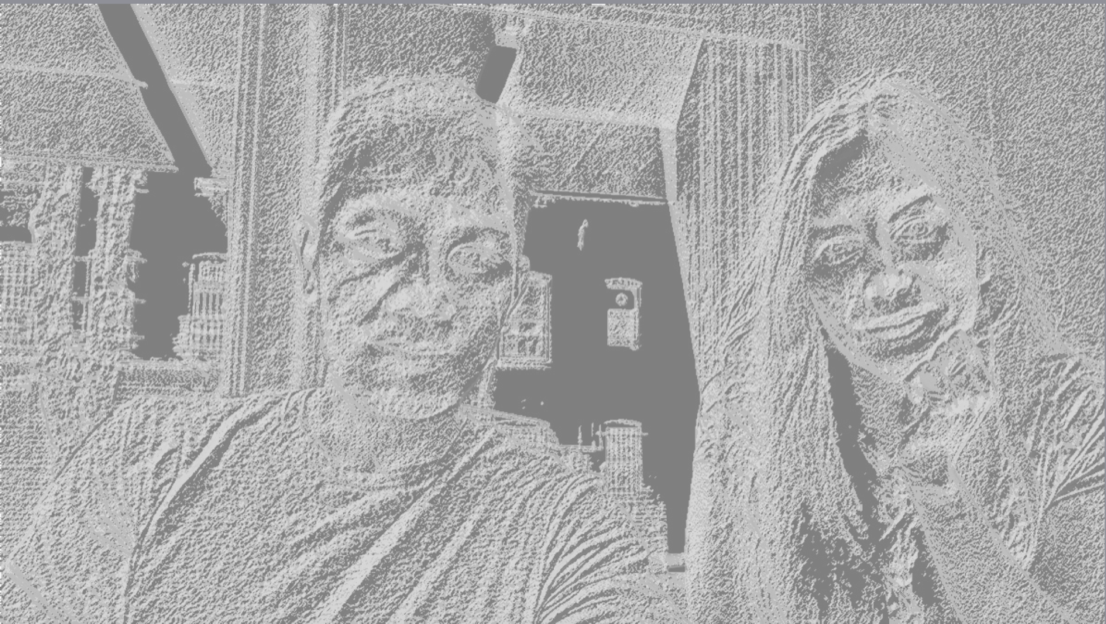

Web Plotly app

Buttons, what do they do

Capture and retrain

**SUMMARY AND CONCLUSIONS**

Summarize the results you obtained, explain what you have learned, and suggest improvements that could be made in the future.

I learned about different types of facial recognition algorithms and their associated pros and cons.

Haar advantages and Disadvantages

HOG advantages and disadvantages

CNN

Haar algorithm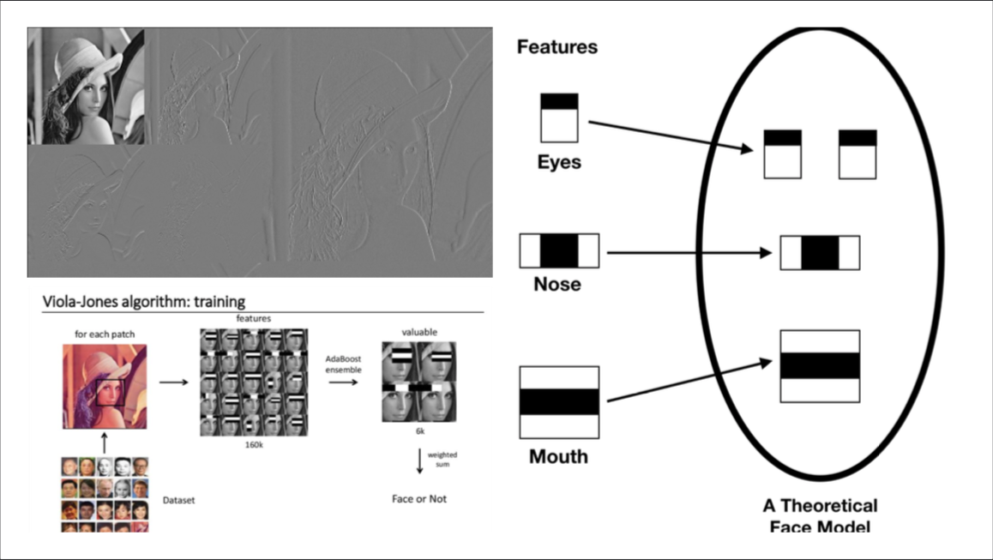

HOG algorithm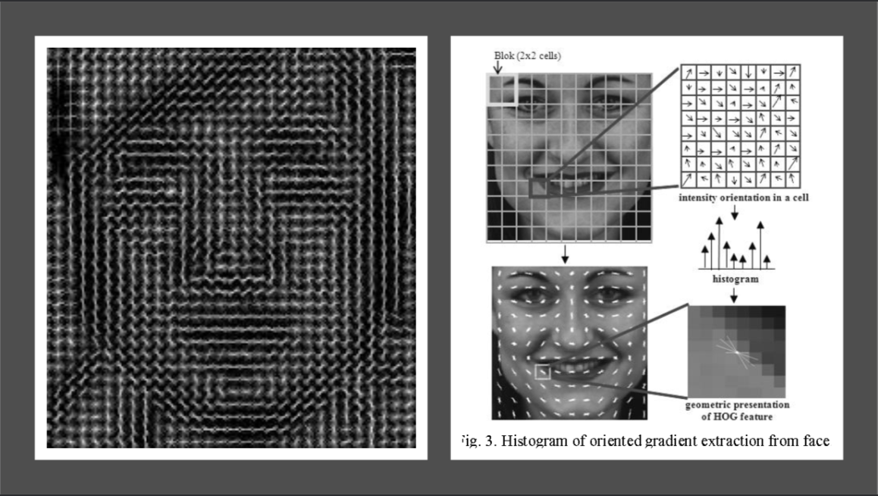

Some improvements that we can do if we have more processing capacity, is train individual cascades for recognition since this will both be fast and accurate. But our time and resources are limited so we decided to use a different route.

In the far future, I want to merge this into a drone or a portable camera to identify people. Since it can be connected to a database in the internet, it can be used to identify and pull information of people identified and can be used for law enforcement purposes.

**Calculate the percentage**

